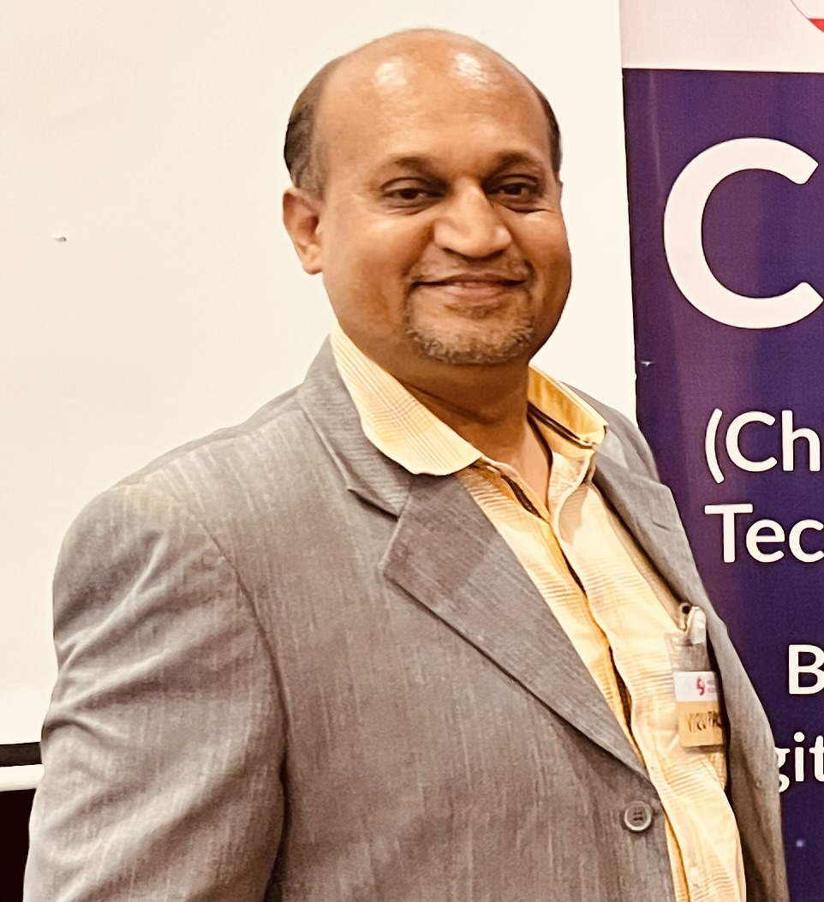

***ANGADI Virupaksh, DIRECTOR - IT***

*BE(E&C), ExeMBA (IIM B), SmartFactory (IISc)*

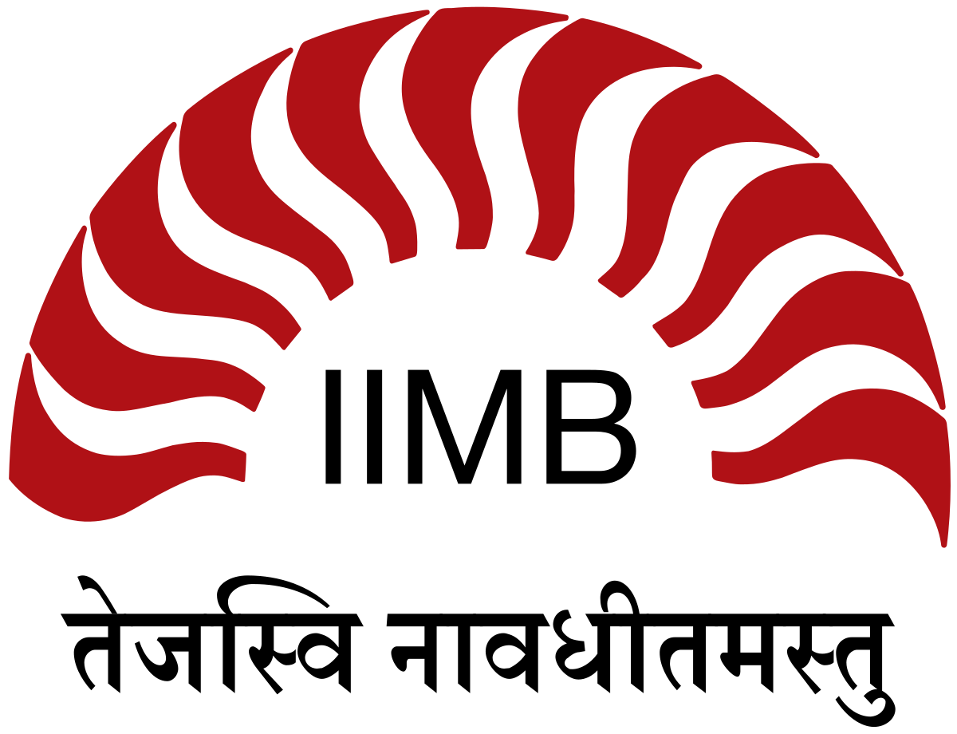

*An ALUMNUS OF IIM BENGALURU*

*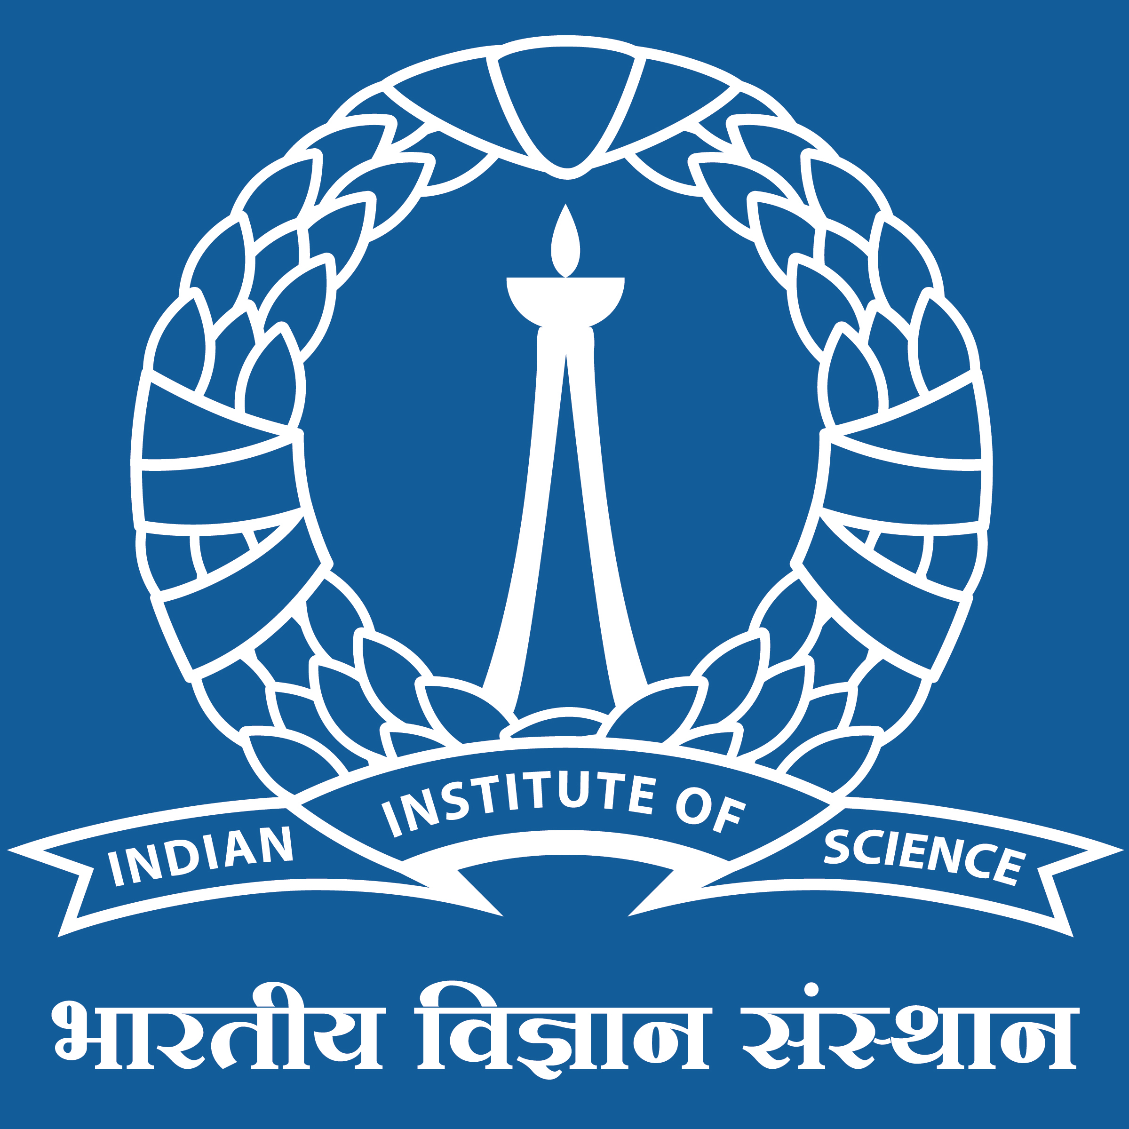IISc BENGALURU - PG Level Advanced Certification*

*in “****Digital Manufacturing & Smart Factory****”.*

***B.E. (ELECTRONICS & COMMUNICATIONS)*** *from BVB COLLEGE OF ENGG & TECH; HUBLI, KARNATAKA.*

* *Total of* ***33 Years*** *of experience in setting up of Corporate IT & Digital Transformation for Global Manufacturing complexes.*
* ***14 Years*** *worked in Middle East & Europe for MNCs.*

***Presently DIRECTOR – IT @ MS RAMAIAH UNIVERSITY & HOSPITALS.***

***Worked for …***

* *3 PSUs (****BEML LTD****,* ***MRPL LTD, KIOCL LTD****) (Govt of India Undertaken).*
* *3 MNCs (JOHNSON CONTROLS INC, COCA COLA INC, ALIAXIS SA -ASHIRVAD PIPES).*
* *3 Private Cos (BASE BATTERIES, GURU SOFTECH, STARTUP).*

*Leadership Strategic IT role in various Manufacturing for digital Transformation in Industries like Steel, Mining, Battery/Inverter/UPS, Beverages, Refinery, Petrochemicals, PVC Pipes, Metro, Defense & Mining Equipment’s, Software, etc.*

*Digital Transformation of large projects implemented :*

* *ERP - SAP S4 HANA, SAP ECC6 ERP, SRM, CRM-Salesforce,*
* *Business Intelligence*
* *Industry4.0*
* *IT Infrastructure Projects*

*Business-centric mind-set to contribute to overall growth & profitability strategy. Transformed businesses for their culture, effectiveness, growth, and efficiencies.*

*He is an early adopter of emerging technologies – RPA, Additive Mfg, AR/VR, Industry 4.0, AI/ML, AIOps, Smart factory, Cloud, SOC, Zero trust technologies, IoT, Operating Technology, eGovernance, Big Data Analytics, Data Lake.*

***CERTIFICATES EARNED:***

*eGovernance, AI/ML, RPA, IoT, Industry4.0, Smart factory, SAP tech tracks, Salesforce, Digital Marketing, Six sigma black belt, EV Technology, Leadership JCI.*

***AWARDS & HONOURS:***

* *CIO100 Excellence Award 2022 by Foundry*
* *CXO Tech Excellence Award 2022*
* *PSU Digital Transformation Leader Award 2021*
* *Industry 4.0 Initiative in Public Sector 2022*
* *CIO NEWS Magazine – Digital Transformation in Defense Sector*
* *CIO Insider India Magazine Jul2022 – RPA Startup*
* *Key Speaker for 8th PSU Digital 2021*

***SOCIAL MEDIA:***

[*https://www.linkedin.com/in/vcangadi-cio*](https://www.linkedin.com/in/vcangadi-cio)